OUTLINE DRAFT 2 October 2 2018

[**Interoperability of Metadata Standards in Cross-Domain Science, Health, and Social Science Applications**](https://www.dagstuhl.de/no_cache/en/program/calendar/evhp/?semnr=18403)

**September 30 – October 5 , 2018, Event 18403**

Authors

Abstract

Introduction

ISC CODATA Data Integration Initiative (Data Interoperability and Integration for Interdisciplinary Research Programmes)

* **Strand 1.** This **addresses important application domains** (infectious disease, resilient cities, and disaster risk, with a possibility of adding agriculture): They are major issues where relevant data exists and is accessible, where the data required comes from multiple sources taken from multiple disciplines, where integration is a tractable objective, and there are existing communities of practice that are willing to collaborate.
  + **Demonstrate the tractable, achievable benefits of data interoperability.**
* **Strand 2** will seek to provide **data infrastructure support for the pilots.** From the point of view of this data infrastructure, the pilot projects are exemplars of cross-disciplinary applications, and thus pathfinders for approaches to data integration, as well as the technical and organizational requirements for disciplines of science that have not yet deployed the technologies and standards necessary for effective data integration in the contemporary (web) informatics environment. … In particular, formalization of discipline-specific vocabularies in an interoperable form is an essential pre-requisite for integration of data from different disciplines.
* **Drawing generic lessons on the actions and support required to promote interoperability and data integration**

Aims and objectives of the workshop

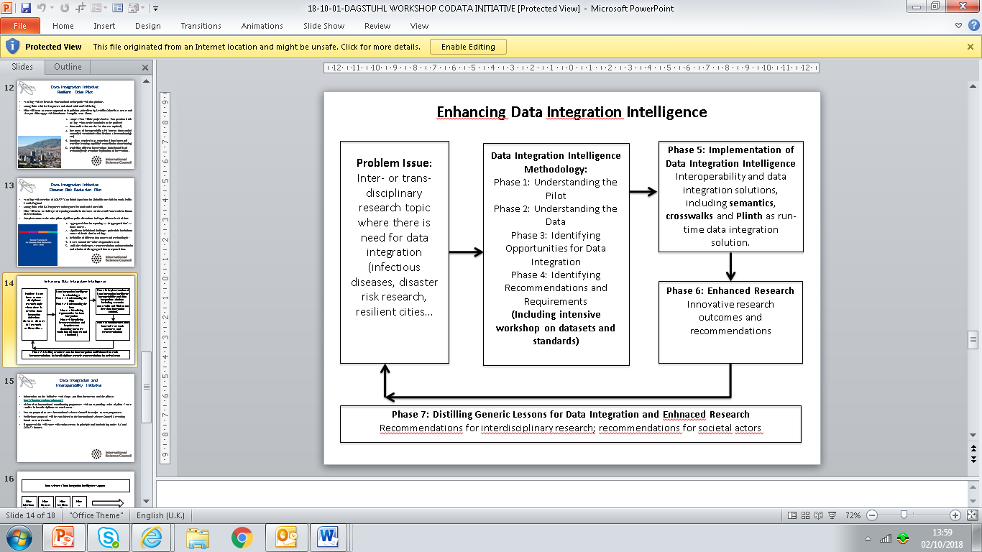

Summary of the three pilots and their proposed outcomes

Links to the different levels of the objectives:

* Process recommendations
* Systems design
* Data and definition issues

Summary of the systems described – details to be included in Annex

Link to Simon Cox’s summary graph and table from Tuesday morning

Steve’s table and Analysis of technical specifications – with Pilot (infectious disease data table outputs details and issues identified include

* Data sets or pools of data

Next steps to engage for delivery

Annex of pilots

Annex of the data scientists presentations